|  |  |
| --- | --- |
| Reported by | Dropdown – Employee/Contractor/NA |
| Reported detail ( Free text) |  |

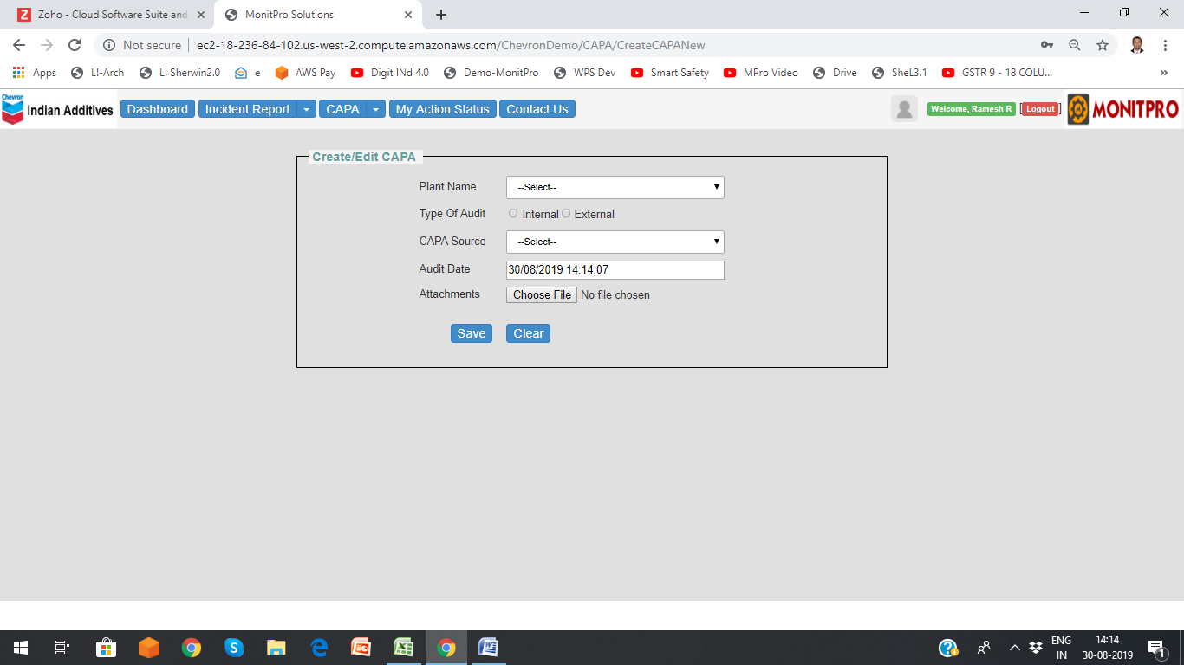



|  |  |
| --- | --- |
| Category (Dropdown) |  |
| Priority (Radio button/DD) |  |

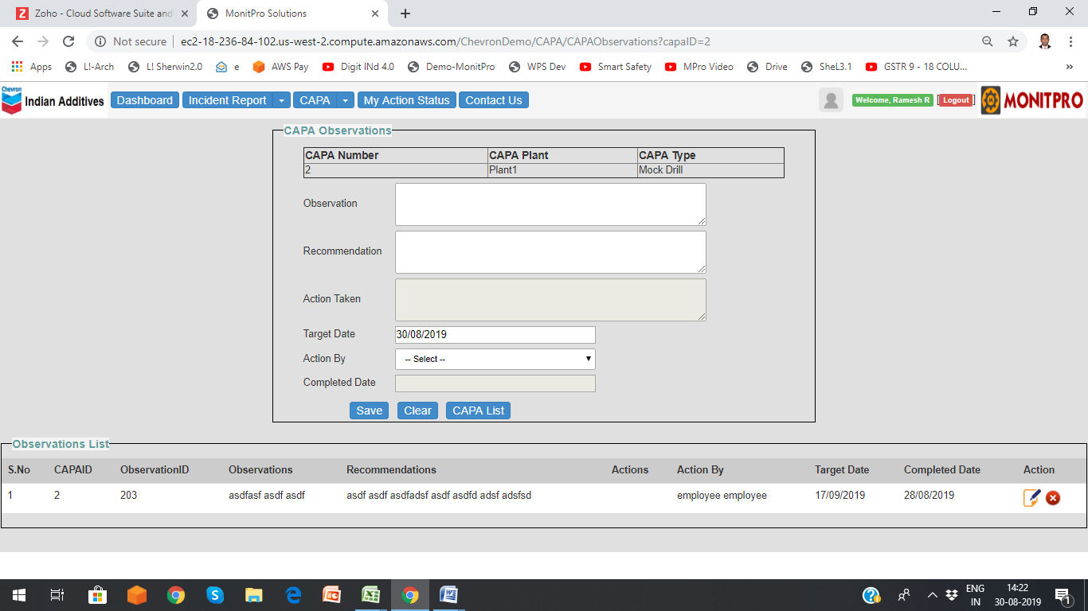

|  |  |
| --- | --- |
| Remarks ( Free text) |  |



New dropdowns, Department, Category, Priority in both Track CAPA and History pages

